**Problem Statement 1:** Demonstrate Various Types of Command for Help in R.

**Objective:** To demonstrate various types of command for Help in R.

**Theory:** R includes extensive facilities for accessing documentation and searching for help. There are also specialised search engines for accessing information about R on the internet, and general internet search engines can also prove useful.

**Command + Output (code starts with “>”):**

> help(“mean”)

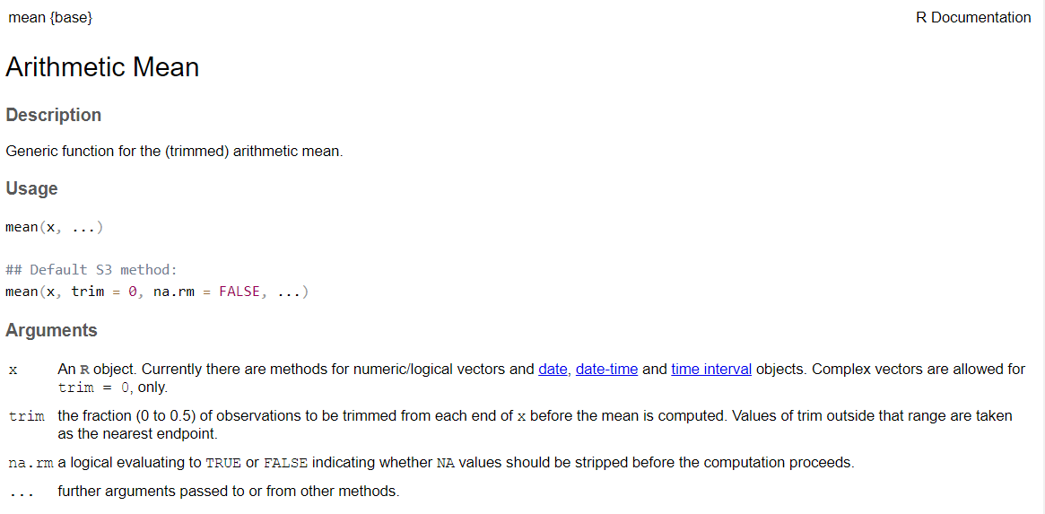

> help.search(“mean”)

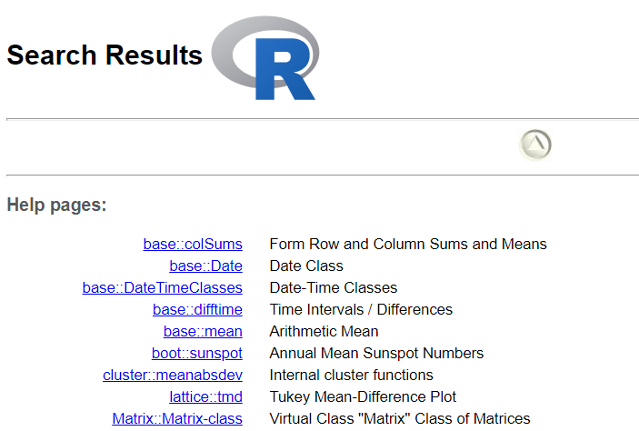

> apropos(“mea”)

[1] ".colMeans" ".rowMeans"

[3] "colMeans" "influence.measures"

[5] "kmeans" "mean"

[7] "mean.Date" "mean.default"

[9] "mean.difftime" "mean.POSIXct"

[11] "mean.POSIXlt" "rowMeans"

[13] "weighted.mean"

> RSiteSearch(“mean”)

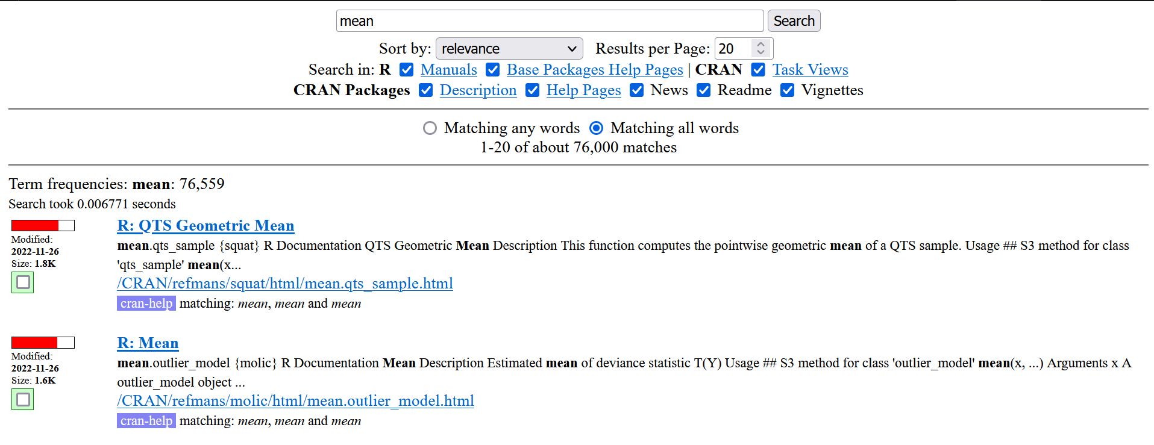

> help.start()

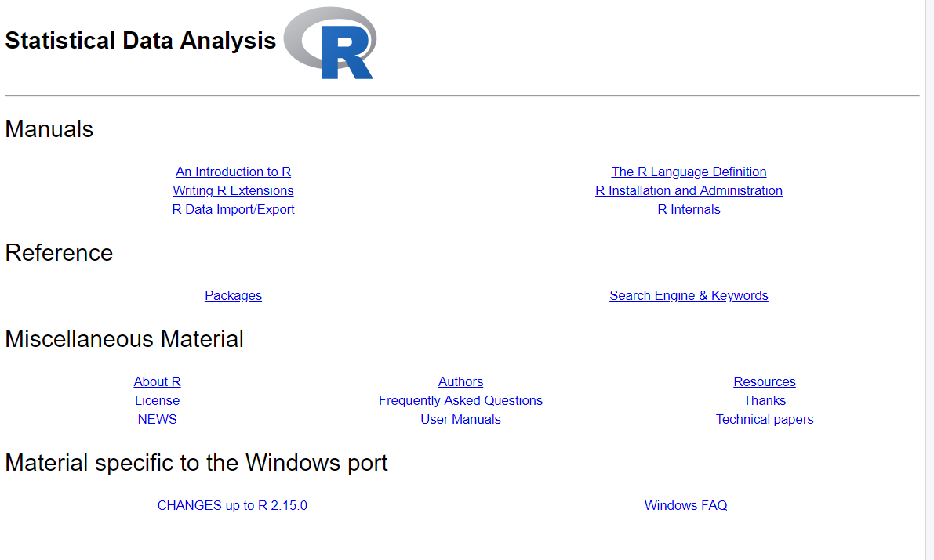

**Problem Statement 2:** Demonstrate Various Command for Packages in R.

**Objective:** To demonstrate various commands for packages in R.

**Theory:** Packages inR programming language are a set of R functions, compiled code, and sample data. These are stored under a directory called “library” within the R environment. By default, R installs a group of packages during installation. Once we start the R console, only the default packages are available by default. Other packages that are already installed need to be loaded explicitly to be utilised by the R program that’s getting to use them.

**Command + Output:**

> search()

[1] ".GlobalEnv" "tools:rstudio" "package:stats"

[4] "package:graphics" "package:grDevices" "package:utils"

[7] "package:datasets" "package:methods" "Autoloads"

[10] "package:base"

> installed.packages()

Package

base "base"

boot "boot"

class "class"

cluster "cluster"

codetools "codetools"

compiler "compiler"

datasets "datasets"

foreign "foreign"

graphics "graphics"

grDevices "grDevices"

……

> library()

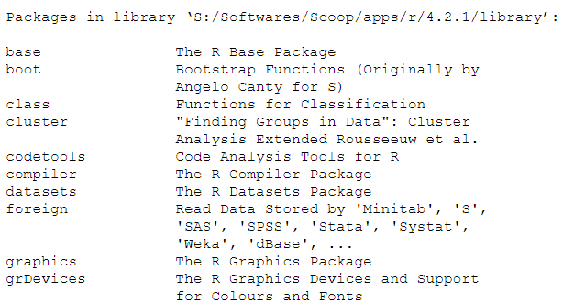

> vignette()

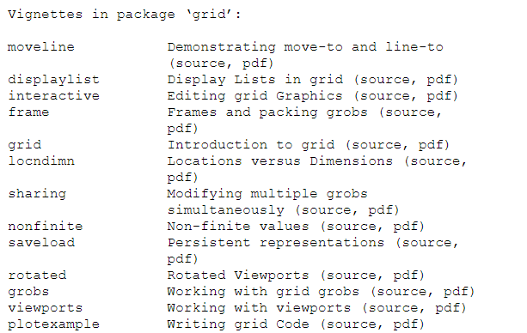

> demo()

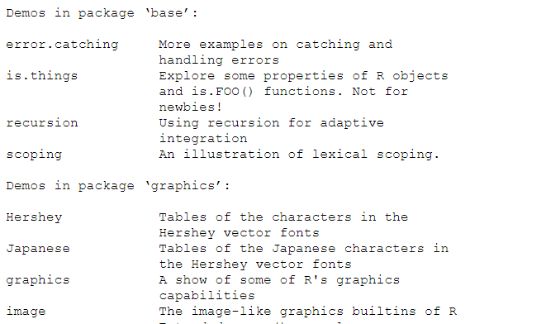

**Problem Statement 3:** How to Use R as a calculator and store the results in R.

**Objective:** To Use R as a calculator and store the results in R.

**Theory:** R can be used as a powerful calculator by entering equations directly at the prompt in the command console. Simply type your arithmetic expression and press ENTER. R will evaluate the expressions and respond with the result.

**Command + Output:**

> 5+4

[1] 9

> 9*4

[1] 36

> 91/2

[1] 45.5

> 52%%3

[1] 1

> 71%/%4

[1] 17

> sqrt(7)

[1] 2.645751

> abs(-199)

[1] 199

> cos(12)

[1] 0.843854

> exp(5)

[1] 148.4132

# Storing result in a variable -

> a <- 9*2+4/2

> a

[1] 20

> b <- cos(11)

> b

[1] 0.004425698

> c <- a+b

> c

[1] 20.00443

**Problem Statement 4:** Demonstrate the usage of variables, constants and built-in constants in R.

**Objective:** To demonstrate the usage of variables, constants and built-in constants in R.

**Theory:**

In computer programming, a variable is a named memory location where data is stored.

Constants are those entities whose values aren't meant to be changed anywhere throughout the code. In R, we can declare constants using the <- symbol.

R programming provides some predefined constants that can be directly used in our program, also known as built-in constants.

**Command + output:**

# Variables and constants

> a <- 99 %/% 12

> a

[1] 8

> b <- "a"

> b

[1] "a"

> c <- "THis is just a test!!!"

> c

[1] "THis is just a test!!!"

> d <- 0/0

> d

[1] NaN

# Built-in constants

> LETTERS

[1] "A" "B" "C" "D" "E" "F" "G" "H" "I" "J" "K" "L" "M" "N" "O" "P" "Q" "R" "S"

[20] "T" "U" "V" "W" "X" "Y" "Z"

> month.abb

[1] "Jan" "Feb" "Mar" "Apr" "May" "Jun" "Jul" "Aug" "Sep" "Oct" "Nov" "Dec"

> pi

[1] 3.141593

**Problem Statement 5:** Demonstrate the usage of all the operators in R

**Objective:** To demonstrate the usage of all the operators in R.

**Theory:**

R supports majorly four kinds of binary operators between a set of operands.

They are -

Arithmetic Operators

Logical Operators

Relational Operators

Assignment Operators

**Command + Output:**

# Arithmetic Operations

> 5+7

[1] 12

> 6^3

[1] 216

> 6%%4

[1] 2

> 6%/%4

[1] 1

# Logical Operations

> list1 <- c(TRUE, 0.1)

> list2 <- c(0,4+3i)

> print(list1 & list2)

[1] FALSE TRUE

> list1 <- c(0,FALSE)

print(!list1)

[1] True True

> TRUE && FALSE

[1] FALSE

> TRUE || FALSE

[1] TRUE

# Relational Operations

> 5 < 10

[1] FALSE

> 10 != 7

[1] TRUE

# Assignment Operation

> vec1 <- c(2:5)

> vec1

[1] 2 3 4 5

> c(2:5) ->> vec2

> vec2

[1] 2 3 4 5

> vec3 <<- c(2:5)

> vec3

[1] 2 3 4 5

> vec4 = c(2:5)

> vec4

[1] 2 3 4 5

**Problem Statement 6:** How to enter numerical and text items as data in R.

**Objective:** To enter numerical and text items as data in R.

**Theory:** We can use combine command for creating data (both numerical and character type).

**Command + Output:**

> a <- c(2, 3, 4, 5, 6, 7)

> a

[1] 2 3 4 5 6 7

> b <- c(a, 1, 99, 1930)

> b

[1] 2 3 4 5 6 7 1 99 1930

> days <- c('Mon', "Tue", 'Wed', "Thurs")

> days

[1] "Mon" "Tue" "Wed" "Thurs"

> days <- c(days, "Fri", 'Sat', "Sun")

> days

[1] "Mon" "Tue" "Wed" "Thurs" "Fri" "Sat" "Sun"

> mixed <- c(b, days)

> mixed

[1] "2" "3" "4" "5" "6" "7" "1" "99" "1930"

[10] "Mon" "Tue" "Wed" "Thurs" "Fri" "Sat" "Sun"

**Problem Statement 7:** Demonstrate the usage of scan command.

**Objective:** To demonstrate the usage of scan command.

**Theory:** Scan command reads data into a vector or list from the console or file.

**Command + Output:**

# Default expects a real number as input

> a <- scan()

1: 1

2: 53

3: 131

4:

Read 3 items

> a

[1] 1 53 131

# Scanning strings

> a <- scan(what="character")

1: kdfok

2: test

3: ok

4:

Read 3 items

> a

[1] "kdfok" "test" "ok"

> a <- scan(sep=",", what="character")

1: just,a,test

4:

Read 3 items

> a

[1] "just" "a" "test"

# Scanning from file

> a <- scan(what="character", file="CCA CRA ParametricEQ.txt")

Read 63 items

> a

[1] "Preamp:" "-4.2" "dB" "Filter" "1:" "ON" "PK"

[8] "Fc" "19" "Hz" "Gain" "-4.7" "dB" "Q"

[15] "0.09" "Filter" "2:" "ON" "PK" "Fc" "568"

[22] "Hz" "Gain" "1.2" "dB" "Q" "1.78" "Filter"

[29] "3:" "ON" "PK" "Fc" "862" "Hz" "Gain"

[36] "1.6" "dB" "Q" "2.87" "Filter" "4:" "ON"

[43] "PK" "Fc" "3213" "Hz" "Gain" "4.0" "dB"

[50] "Q" "1.88" "Filter" "5:" "ON" "PK" "Fc"

[57] "13" "Hz" "Gain" "-0.6" "dB" "Q" "1.10"

**Problem Statement 8:** How to show and set the default working directory in R.

**Objective:** To show and set the default working directory in R.

**Theory:**

The working directory is just a file path on your computer that sets the default location of any files you read into R, or save out of R.

You can only have one working directory active at any given time. The active working directory is called your *current* working directory.

You can also change the working directory.

**Command + Output:**

# To show current working directory

> getwd()

[1] "C:/Users/lucky"

# To change working directory

> setwd("S:/Downloads")

> getwd()

[1] "S:/Downloads"

**Problem Statement 9:** Write a R script to take input from user for addition of two numbers.

**Objective:** To take input from the user for the addition of two numbers.

**Theory:**

readline() function used to read input from the user.

as.double() function used to transform read data into a double.

print() function to print data to console.

paste() to concatenate vectors after converting to character.

**R Script:**

a <- as.double(readline(prompt = "Enter first number to add: "))

b <- as.double(readline(prompt = "Enter second number to add: "))

print(paste("The sum of entered numbers", a, "and", b, "is", a+b))

**Output:**

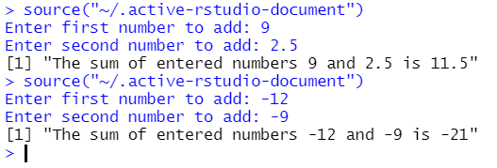

**Problem Statement 10:** Write a R script to input a number check if the number is positive or negative or zero.

**Objective:** To input a number and check if the number is positive or negative or zero.

**Theory:**

readline() function used to read input from the user.

as.double() function used to transform read data into a double.

print() function to print data to console.

if() function checks whether a condition is TRUE or FALSE.

**R Script:**

num = as.double(readline(prompt="Enter a number: "))

if(num > 0) {

print("Entered number is a positive number.")

} else if (num < 0) {

print("Entered number is a negative number.")

} else {

print("Entered number is 0.")

}

**Output:**

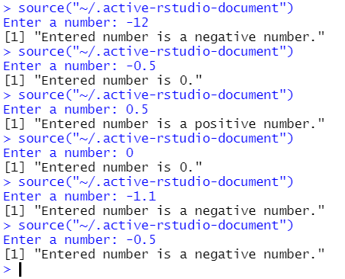

**Problem Statement 11:** Write a R script to check if the input number is odd or even.

**Objective:** To check if the input number is odd or even.

**Theory:**

readline() function used to read input from the user.

as.integer() function used to transform read data into an integer.

print() function to print data to console.

if() function checks whether a condition is TRUE or FALSE.

**R Script:**

num = as.integer(readline(prompt="Enter a number to check if its even or odd: "))

if(num %% 2 == 0) {

print("Entered number is an even number.")

} else {

print("Entered number is an odd number.")

}

**Output:**

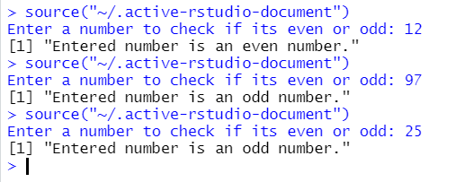

**Problem Statement 12:** Write a R script to find the multiplication table of inputted number.

**Objective:** To find the multiplication table of inputted number.

**Theory:**

readline() function used to read input from the user.

as.integer() function used to transform read data into an integer.

print() function to print data to console.

for() function repeats statement as long as condition is TRUE.

**R Script:**

num = as.integer(readline(prompt="Enter a number to show multiplication table of: "))

for (i in 1:10) {

print(paste(num, "*", i, "=", num*i))

}

**Output:**

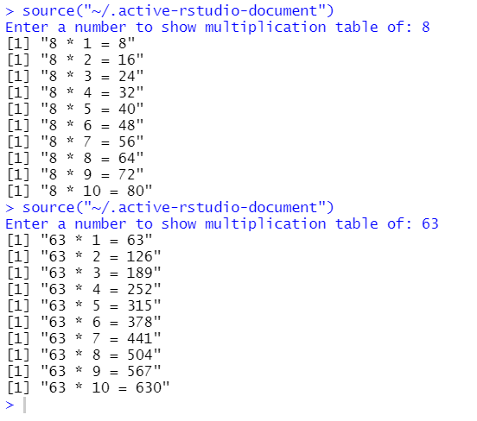

**Problem Statement 13:** Write a R script to find the factorial of a number without using factorial function.

**Objective:** To find the factorial of a number without using factorial function.

**Theory:**

readline() function used to read input from the user.

as.integer() function used to transform read data into an integer..

print() function to print data to console.

for() function repeats statement as long as condition is TRUE.

**R Script:**

num = as.integer(readline(prompt="Enter a number to find factorial of: "))

fac = 1

for (i in 2:num) {

fac = fac * i

}

print(paste("Factorial of", num, "is", fac))

**Output:**

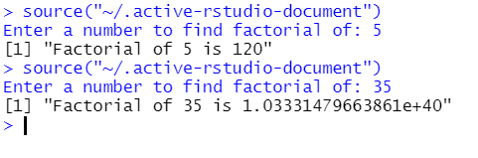

**Problem Statement 14:** Write a R script to check if the input number is prime or not.

**Objective:** To check if the input number is prime or not.

**Theory:**

readline() function used to read input from the user.

as.integer() function used to transform read data into an integer..

print() function to print data to console.

for() function repeats statement as long as condition is TRUE.

sqrt() function returns the square root of the argument.

**R Script:**

num = as.integer(readline(prompt="Enter a number to check whether its prime or not: "))

prime = 1

if (num == 0 || num == 1) {

prime = 0

} else {

for (i in 2:sqrt(num)) {

if (num %% i == 0) {

prime = 0

}

}

}

if (prime == 1) {

print(paste("Entered number", num, "is a prime number."))

} else {

print(paste("Entered number", num, "is NOT a prime number."))

}

**Output:**

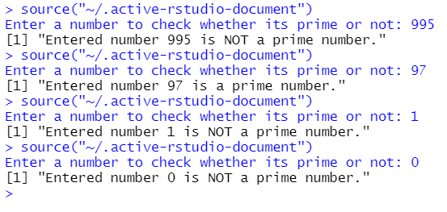

**Problem Statement 15:** Write a R script to check whether the number is palindrome or not.

**Objective:** To check whether the number is palindrome or not.

**Theory:**

readline() function used to read input from the user.

as.integer() function used to transform read data into an integer..

print() function to print data to console.

while() function repeats statement as long as the condition is TRUE.

**R Script:**

num = as.integer(readline(prompt="Enter a number to check whether its a palindrome number or not: "))

copy_num = num

rev = 0

while (copy_num != 0) {

rem <- copy_num %% 10

rev <- (rev * 10) + rem

copy_num <- copy_num %/% 10

}

if (rev == num) {

print(paste(num, "is a palindrome number."))

} else {

print(paste(num, "is not a palindrome number."))

}

**Output:**

